**Digital Photography II**

**Instructor: Ms. Hofstetter**

*“Photography deals exquisitely with appearances, but nothing is what it appears to be.”*

*“*[*Trust that little voice in your head that says "Wouldn't it be interesting if.."; And then do it.*](http://thinkexist.com/quotation/trust_that_little_voice_in_your_head_that_says/202864.html)”

- Duane Michals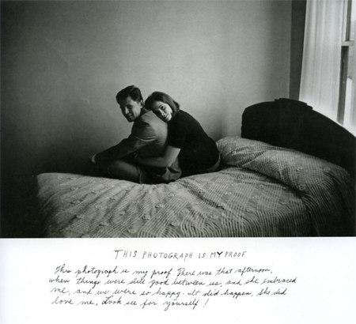

**Welcome back to photography! If you are in this class, it means that you should have already taken, enjoyed, and passed Digital Photography. This class will help you to continue learning about the technical and artistic aspects of digital photography. Specifically, you can expect to:**

* **Create an impressive photography portfolio that includes your best work**
* **Demystify all of those technical camera concerns such as depth of field, exposure, white balance, ISO, focal length…**
* **Clarify all of those technical digital/editing concerns such as resolution, file formats, color correction, filters, printing, scanning…**
* **Spend a lot of time doing what you love – shooting, editing, and printing images that reflect your own personal vision.**
* **Work on a term project of your choosing (based on your own interests) as you also work on shorter projects designed to challenge your creative and critical thinking skills.**
* **Learn to trust that little voice inside your head that says “what if…” and develop your artistic point of view.**
* **Perhaps even discover that “nothing is what it appears to be.”**

**What you need for this class:**

* **Sketchbook – mostly for collecting and organizing images like a scrapbook. You will also use it to take notes, respond to the work of photographers, and write down ideas for projects. You may use one from another class if you still have pages left. 8.5 x 11 inches is a perfect size.**
* **I will give you a manila envelope for prints and contact sheets, as in Digital Photo.**
* **Cameras are here for you as usual, but you may use your own if you prefer. It must be a digital SLR – no point and shoot cameras! It doesn’t matter if it’s Nikon or Canon. Please be sure that you have parental approval to bring in or use a family camera!**
* **Enthusiasm and an open mind. I know that this class only accounts for approximately 1/8 of your day, but it is an advanced elective, which means that you should be eager to learn and consider new ideas.**

**This leads me to what I expect from you:**

* **Respect for classmates, equipment, and me! “Kindness first” is my motto for the year. It’s so easy to take a bad day out on someone else – let’s not do it in here! Please let me know if you are having a hard time - with anything – and if you need help at any time. Don’t take your frustrations out on me, the person next to you, or on $600 cameras or $1500 computers.**
* **Be on time, be prepared with homework (expect some), be where you are supposed to be – whether you are out shooting or in class editing/printing/watching/listening.**
* **Take creative risks. You are no longer a beginner and you should push yourself to be more confident and daring as a photographer. This does not mean that you should put yourself in physical danger to get a dramatic shot! It means that you should try new angles, subject matter, settings, etc.**
* **Be responsible – return cameras on time so that other students may use them, delete your images after uploading, keep your computer files organized, remember to log off at the end of class, no food or beverages near computers, keep track of your prints/envelope, etc.**
* **Enjoy yourself! No one should be in this class unless he/she really wants to be here! It’s not required – it’s a special time you are devoting to an art form that you really like/love. I’m here to help you pursue a personal interest. We have amazing equipment and supplies. This class should be your happy place. I encourage you to come in during frees whenever the room is available.**
* **Please e-mail me anytime:** [**dhofstetter@scarsdaleschools.org**](mailto:dhofstetter@scarsdaleschools.org)**. I may not be able to get back to you immediately, but I will always respond asap.**
* **Please check my Schoolwires Digital Photo II page for assignments, reminders, and resources.**
* **My schedule is posted on the doors of rooms 206 and 211. My office is inside the classroom in 211, but most of my classes are in 206.**

**I am really excited to work with you all. Let’s have a creative and productive semester!**