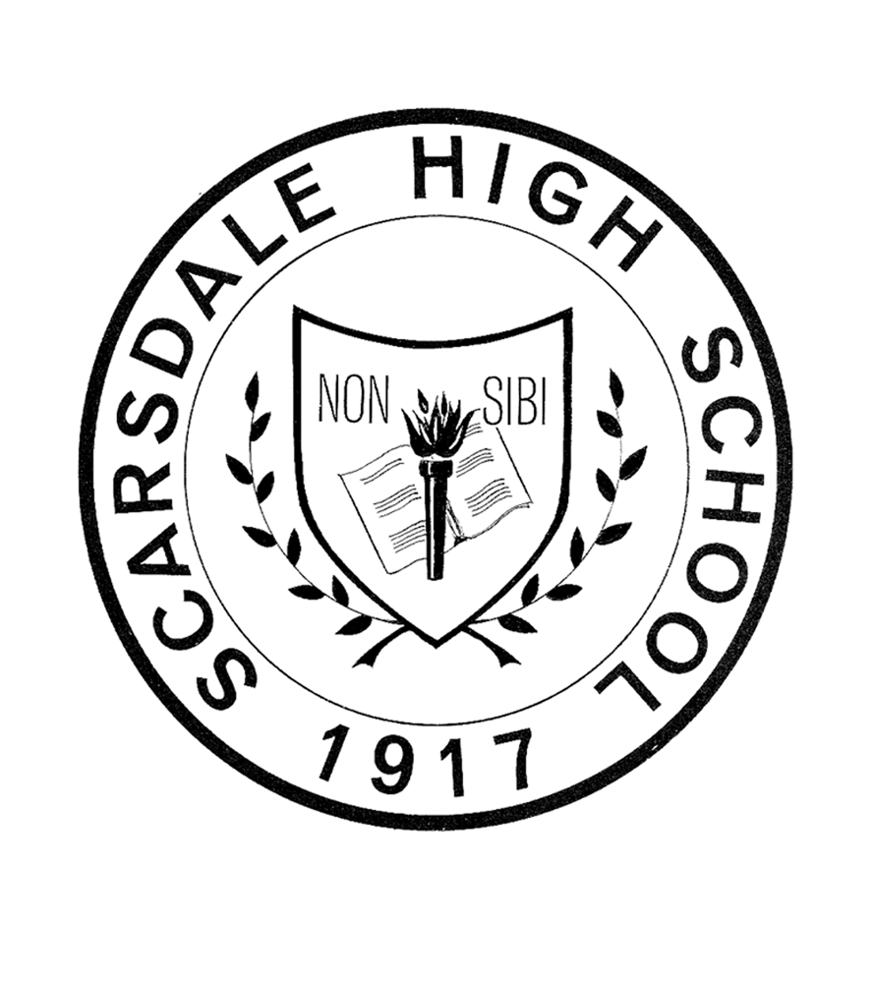
SCARSDALE HIGH SCHOOL

ENGLISH DEPARTMENT
TWELFTH-GRADE COURSE CATALOG

ACADEMIC YEAR 2015-2016

The following courses have been designed to meet the varied interests, talents, and needs of twelfth-grade students. After reading the course descriptions and discussing them with teachers, parents, deans, and friends, indicate your preference by completing the selection sheet that you were given and returning it to your English teacher.

ENGLISH 242
“STAYING ALIVE”

Like English 232, its precursor, this course offers students the opportunity to study a full range of literary genres — novels, plays, poetry, and essays — and to concentrate on improving their writing skills. Students will continue their studies of both classic and modern literature and write both essays and creative papers. All students will apply the principles of research to the writing of a fully documented research paper. Class size for this course is limited in order to facilitate an especially close working relationship between students and teacher.

The curriculum, which includes works by writers from a wide range of backgrounds and cultures, focuses on the theme of the pursuit of self-knowledge, hence its title: Staying Alive. What does it mean to survive and be a survivor? What can nourish or sustain us as we go through life? Sheer will? Determination? Spirit? Some combination of the three? If disaster strikes, how does one overcome it? How does one gather courage? From where does inspiration come? How do race, gender, and culture shape our lives? How can we change in the face of profound challenges and daunting odds?

These questions can help us explore survival through a wide range of literary and film experiences, whether we find ourselves on a mountaintop along with the survivors of a plane crash, or we travel to Mexico to taste the bitterness of a mother’s wrath, or, more positively, we make our way to Japan and sip the broth of fragrant soba noodles made by a loving woman. Through these experiences that are both local and global, we can formulate the questions and answers that will help us to know ourselves better. This course is a “moveable feast,” so let’s partake. Let’s indulge ourselves.

TEXTS:
Erdrich, L. Love Medicine
Esquivel, L. Like Water for Chocolate
Hammett, D. The Thin Man
Hemingway, E. The Nick Adams Stories
Hillerman, T. A Thief of Time
Ibsen, H. A Doll's House
Orwell, G. 1984
McCall, N. What’s Going On?
Miller, E. In Search of Color Everywhere
Mori, O. The Wild Geese
Phillips, C. Cambridge
Read, P.P. Alive: The Story of the Andes Survivors
Segal, E. Love Story
Yoshimoto, B. Kitchen
Selected essays and short stories

FILMS: Keep the River on Your Right; Start-up.com; Moonstruck; Soldier’s Home; The Graduate; Eat, Drink, Man, Woman

ENGLISH 243
English Selectives

Students who take English 243 will be enrolled in one of this course’s three selective offerings—“Words and Images,” “The Self as Writer,” or “Dilemmas”—that are designed for the majority of seniors, those who are at ease in their English studies. Seminal works, primarily by British and European authors, make up the core of the curriculum and are supplemented by titles of particular relevance to each of the selectives. Students will apply the principles of research to the writing of a fully documented research paper. They will also have opportunities to study and write about contemporary literature and media. The selectives share a core curriculum, yet each has a specific focus. Details follow.

CORE CURRICULUM FOR ALL ENGLISH 243 SELECTIVES

Students will study several key literary works of the Western Canon:

- one Greek drama, e.g., Medea; Oedipus, Rex, etc.
- a Shakespearean play, e.g., Hamlet; Othello, etc.
- a nineteenth-century novella or novel, e.g., Frankenstein, The Strange Case of Dr. Jekyll and Mr. Hyde, Wuthering Heights, etc.
- two weeks of non-American poetry

SELECTIVES CURRICULA

Students will study the following in proportions appropriate for the elective they choose:

- essays for both analysis and as models for personal writing
- multimedia as both art forms and tools of persuasion
- literature and multimedia that address questions about identity and selfhood
- literature, multimedia, and philosophy that illustrate moral dilemmas that help to shape one’s sense of self

Selective C1371
WORDS AND IMAGES

We turn to CNN and think we understand the world; we glance at an ad for Tiffany’s and think we have found the good life; we watch Braveheart and think we have glimpsed the past. But what we understand is partial, what we have found is superficial, what we have glimpsed is fabricated. Such images are insidious. They even invade our dream-space. They are not our creations; they are our creators.

This is no hyperbole. Mass-produced images – whether films or videos or commercials or ads – produce us. They do not just convey information; they become experience. They do not just structure knowledge; they become knowledge. They flicker on the wall of our electronic cave as we stare, transfixed. The media are most certainly the message.

If we are not to confuse ourselves with someone else’s version of who we are, we must learn to deconstruct this message, to read these images the way we do a cereal box or a sonnet. We must decode their language, scrutinize their syntax, and analyze their tropes. If we are to break through the tunnel vision that the media induce, we must do more than react— we must change from passive observers into active viewers.

But this transformation, while necessary, is not sufficient. We live now in a world that is perpetually fifteen minutes old, a world as flat as an LCD screen, a world in which the trivial and the significant are frequently indistinguishable. If we are to move beyond the context of no context, we must not only look more closely; we must read more widely. We must connect the images that bombard us to the words that are our inheritance, for it is the word that gives the image its texture, its shading, its depth. So this is also a course in connections: Agamemnon at the walls of Troy to George W. Bush on the highway to Baghdad; Shakespeare’s Iago to a high-flying Madison Avenue ad exec; Kafka’s Gregor Samsa to the horrors of the Holocaust; Sophocles’ ill-fated Oedipus to the memory-impaired protagonist of Christopher Nolan’s Memento; Anthony Burgess’s Alex sitting in the Korovo Milkbar to any of us gazing into a computer screen.

For, since we are what we see, we must learn to see more wisely.

TEXTS:
Barker, P. Regeneration
Bronte, E. Wuthering Heights
Burgess, A. A Clockwork Orange
Carroll, L. Alice’s Adventures Underground
Clarke, A. Childhood’s End
Conrad, J. Heart of Darkness or “A Secret Sharer”
DeLillo, D. White Noise
Euripides Medea
Esquivel, L. Like Water for Chocolate
Homer The Iliad (excerpts)
Highsmith, P. The Talented Mr. Ripley
Ingalls, R. Mrs. Caliban
O’Brien, T. In the Lake of the Woods
Orwell, G. 1984
Plato The Republic
Shakespeare, W. Othello; Hamlet; etc.
Shaw, G. B. Pygmalion
Shelley, M. Frankenstein
Sophocles Oedipus, Rex

FILMS:
Apocalypse, Now
Brazil
Citizen Kane
Do the Right Thing
Election
Gallipoli
Hamlet
M
Memento
Metropolis
Olympiad
Othello
Rear Window
Some Like It Hot
Strangers on a Train
The Deer Hunter
FILMS: (cont’d)

The Manchurian Candidate
The Talented Mr. Ripley
The Truman Show
Tootsie
Triumph of the Will
Twelve Monkeys
Vertigo

Selective C1372
THE SELF AS WRITER

The impulse to share stories is a strong one for many, but the opportunity to do so in an academic setting is rare. So often the storyteller in each of us must take a back seat to the analyst, the critic, and the problem solver, and our creative voices are muffled. In this course, however, analysis becomes the vehicle for creative exploration. Students will read and discuss works by Beckett and Shakespeare, for example, with the goal of trying to emulate aspects of their craft. Instead of writing an expository essay on Salman Rushdie’s Haroun and the Sea of Stories the class will focus on writing its own fiction, using Rushdie’s work as a model. Imagination will also play a part in the study of literature as students are asked to reconsider and rewrite the stories of classic heroes from the perspectives of supporting characters. How, for example, might Ophelia articulate her views on the situation in Denmark and the reason for her untimely end?

The course will foster the development of a supportive community of writers. Students will share their work, listen to others’ work, and offer praise as well as constructive criticism. In their dual roles as writers and workshop members, they will develop a fluency in discussing literary techniques and identifying the qualities of good writing.

Students will also study poetry, personal essays, and short stories, all with the goal of broadening their ability to express themselves in various modes and genres.

The traditional research paper will be a stepping-stone for a larger, more personal, final writing project. For this segment of the course, students will be asked to immerse themselves in the writings of an author whose work they find especially resonant, with the aim of identifying and discussing defining characteristics of the author’s body of work. Having completed a research paper on their chosen author, the students will put together samples of their own writing, each of which will have been inspired by the subject of their study.

TEXTS:
Austen, J. Pride and Prejudice
Baker, R. Growing Up
Bronte, C. Jane Eyre
Carroll, L. Alice’s Adventures in Wonderland
Didion, J. Slouching Towards Bethlehem
Euripides Medea
Lahiri, J. The Namesake
McCourt, F. Angela’s Ashes
Perrine, L., ed. Sound and Sense
Rhys, J. Wide Sargasso Sea
Rushdie, Salman Haroun and the Sea of Stories
Sedaris, D. Me Talk Pretty One Day
Dress Your Family in Corduroy and Denim
Shakespeare Othello; Hamlet; etc.
Shapard, R., ed. Sudden Fiction
Stoker, B. Dracula
Sophocles Oedipus, Rex
Wilde, O. The Picture of Dorian Grey

FILMS:

Frankenstein
Hamlet
Memento
Othello
The Talented Mr. Ripley

Selective C1373
DILEMMAS

Imagine that you are on a hike with your brother and his best friend, and you stumble on a small plane that crashed in the woods. You find 10 million dollars inside, but you know it is drug money. What do you do? Should you turn in the money or keep it? Let’s say you decide to keep the money, but you suspect that your brother and his best friend are plotting against you. How far would you go to keep it all for yourself? Would you kill?

Or imagine that on the night of your wedding, your old lover shows up and tells you he really loves you — always loved you — and wants you back. You look across the room at the person you are supposed to marry. What do you do? Do you run away with your old lover? Forget about your spouse-to-be?

Dilemmas like these flash before our eyes every night in the media. Some are real-life situations that shock us; some are fictional stories that exhilarate us. Sometimes we cannot tell the difference between fact and fiction. Sometimes, because Julia Roberts’ character in Pretty Woman is able to “land” the rich man, we forget that she was a prostitute; sometimes we forget about the deplorable goals of Tyler Derden in Fight Club because Brad Pitt is playing that role. Sometimes, because a person is famous, we believe he or she is making decisions that are right for us. But are they?

How do we learn to see accurately and make sound, ethical decisions in a world saturated with media? Can we simply watch TV and movies without being critical viewers? And is it enough to be informed? Can we just absorb news stories that show us atrocities and inhumane behavior, or should we do something about the suffering?

We see images of husbands and wives who leave their spouses for money, adventure, and fame; children who steal from their parents; characters in shows who cheat, steal and lie to get to the “top”; and companies that knowingly poison rivers to save a few dollars. Does the avalanche of movies, TV shows, and news stories help us to solve our philosophical and ethical dilemmas or tempt us to be like these people on TV? Can Oprah and Dr. Phil help us find happiness and guidance, or are they part of the blitz of too much information? How can we find a balance between what we want and what we need?

Once upon a time you were told, “You can’t always get what you want.” Now the mantras seem to be “Go for it” and “You can have it all.” A devil hovers over one shoulder; an angel hovers over the other. Which one do you listen to?

TEXTS:
Chaucer, G. Canterbury Tales (selections)
Conrad, J. Heart of Darkness or “A Secret Sharer”
DeLillo, D. White Noise
Euripides Medea or The Trojan Women
Hornby, N. How to Be Good
About a Boy
Hosseini, K. The Kite Runner
Huxley, A. Brave New World
Ibsen, H. A Doll’s House or Hedda Gabler
Lorca, F. G. Blood Wedding or Jerma or House of Bernada Alba
Neitzche, F. Beyond Good and Evil
Neruda, P. Selected Poems
Orwell, G. 1984
Ozeki, R. My Year of Meats
Plato The Republic (selections) or Crito or The Apology
Postman, N. Amusing Ourselves to Death (selections)
Schlink, B. The Reader
Shakespeare Hamlet or Othello
Shelley, M. Frankenstein
Singer, P. How Are We to Live? (selections)
Stevenson, R. L. The Strange Case of Dr. Jekyll and Mr. Hyde
Sophocles Oedipus, Rex
Unamuno, M. Abel Sanchez or The Tragic Sense of Life
Greek and World Mythology (selections)

FILMS:
A Simple Plan
Bend It Like Beckham
Central Station
Cheaters
Do the Right Thing
Gattaca
Ground Hog Day
Hamlet
Memento
Mystic River
Office Space
On the Waterfront
Philadelphia
Return to Paradise
Run, Lola, Run
Searching for Garcia Lorca
Sliding Doors
Some Like It Hot

Selective C1374
MAN & HIS ENVIRONMENT

"If we want things to stay as they are, things will have to change."
--Giuseppe Tomasi di Lampedusa, in The Leopard
Over forty years ago, C. P. Snow wrote that "the intellectual life of the whole of western society" was split into the two cultures, the sciences and the humanities; this split, he asserted, was a major impediment to addressing the world's problems. This course will address this split through an integrated, interdisciplinary approach to the study of the environment.
The earth is an interconnected system on which human beings have long had and continue to have a huge impact. The physical and natural sciences are necessary to the study of this system, but they are not sufficient. By complementing these sciences with the perspectives of English and the other humanities, this course will enable students to examine environmental problems through a variety of lenses. They will study not only the science of these problems, but also the role of cultural, social, and economic factors in causing them, and of media in presenting and debating them. Only then can students devise ways of approaching “real world” problems that resist perfect solutions and instead require the balancing of opposing priorities and conflicting interests.
Only then can they put into practice the sage words of di Lampedusa.
Students enrolled in this course will also be enrolled in Environmental Science and the two courses will be linked.

TEXTS:

FILMS:

English 245
ADVANCED TOPICS ENGLISH

The dying Hamlet entreats his friend Horatio to “absent thee from felicity awhile”; the Danish prince wishes his story to be told. We understand why. We may be, as Aristotle said, political animals, but we are equally creatures and creators of narrative. We are not the sum of our experiences but the stories that we make of them; any given moment of our lives can be the climax of one tale and the opening episode of another.

But, we might wonder, what sort of story would Horatio tell? A measured history of international conflict and dynastic struggle in which Hamlet would play but a part? An ironic comedy of manners that begins “The Prince of Denmark was handsome, clever, and sad”? Would he present a naturalistic slice of Danish life or a stream-of-consciousness glimpse of Hamlet’s inner world? Where would he begin? With Hamlet’s father slaying old Fortinbras? Or with the night he first met the prince in a Wittenberg pub? And what of the story’s audience, the listener or the reader? Would a Norwegian hear the story in the same way as a Dane? Would a twentieth century existentialist find in it what a nineteenth century romantic would? Would a theologian and a psychoanalyst agree on what they had read?

This is a course in great literature, about how it is constructed and how we go about reading it. It is an investigation into the way literature invites and confounds interpretation, in the way meanings multiply and vanish. It examines how a work can be two things at once, both jingoistic and anti-war, both epic and absurd, how it can both embrace and satirize the society it depicts. It is a course that revels in irony, feasts on complexity, celebrates ambiguity. After all, as Flaubert wrote, literature is a “perpetual orgy.”

Advanced Topics English is for the most able students of English who also have a deep passion for the discipline. Course topics vary yearly, depending on the interests of teachers and students, as do the readings, all of which are challenging texts that are generally taught in college. Students will hone their close-reading skills, learn a wide range of modes of literary discourse, and explore and emulate the finer points of the writing craft. Juniors in honors English already qualify for this course if they maintain a grade of at least “B-” in that course.

TEXTS:
Austen, J. Emma; Mansfield Park
Beckett, S. Waiting for Godot
Brecht, B. Mother Courage
Conrad, J. Heart of Darkness
Crace, J. Being Dead
Dostoevsky, F. Crime and Punishment
Faulkner, W. As I Lay Dying
Flaubert, G. Madame Bovary
Forster, E. M. A Passage to India
Gordimer, N. My Son’s Story
Huxley, A. Brave New Word
James, H. The Turn of the Screw
Kafka, F. The Metamorphosis
Kingsolver, B. Prodigal Summer
Ishiguro, K. The Remains of the Day
McEwan, I. Atonement
Morrison, T. Beloved
Shakespeare, W. Hamlet; King Lear; The Tempest; Othello
Swift, J. “A Modest Proposal”
Tolstoy, L. “The Death of Ivan Ilych”
Voltaire, F. Candide
Woolf, V. Mrs. Dalloway; A Room of One’s Own; To the Lighthouse

POETRY: The Metaphysicals, the Moderns, the Contemporaries, and more.

