Physics Laboratory Expectations – Vaughan

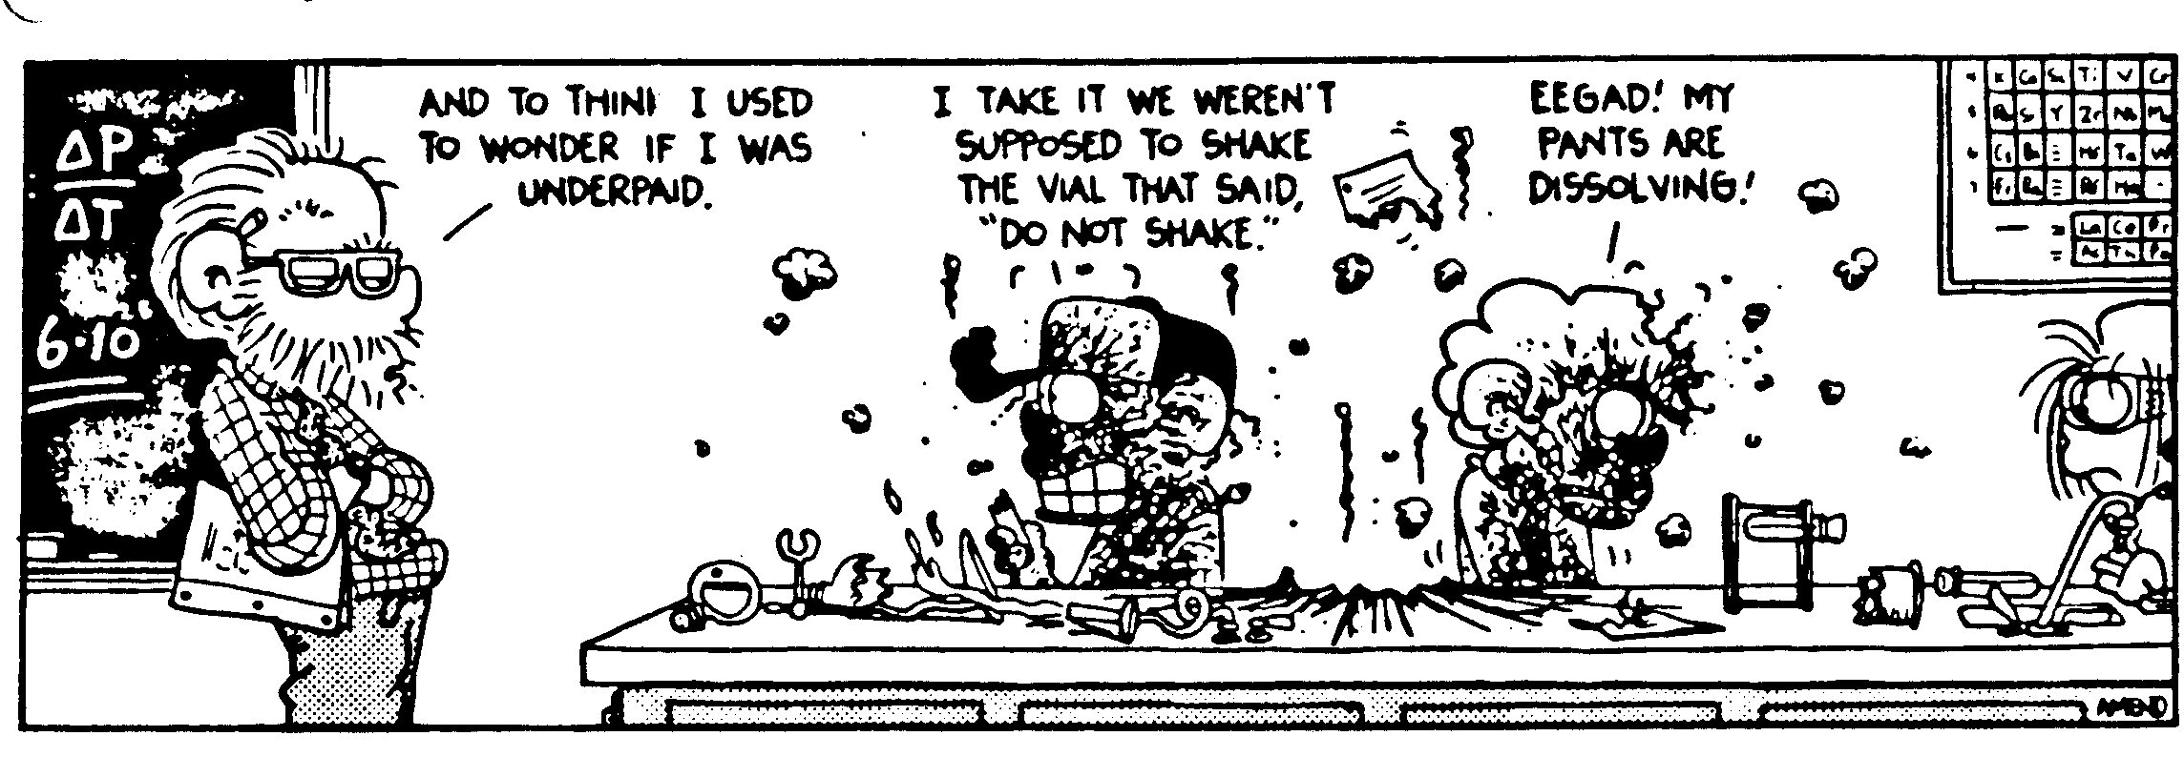
Every quarter, you will be assigned to a laboratory group of about 4 people with whom you will do the majority of your experimental work. After performing each lab, you will be expected to turn in a written report about that lab. These reports vary in their format: some will be formal lab write-ups and others will be more worksheet-based. Here are a few general ideas that will be consistently followed for most labs:
- All labs will require an ABSTRACT unless specified in class. I’ll describe an abstract on the next page.
- All questions for labs must be typed unless space is specifically provided on the lab sheet. (If you are unsure about what to do for a particular lab, don’t suffer in silence – ASK!)
- The expectation is that ONE SAMPLE calculation of each type of calculation must be shown.
- All abstracts must be typed.
- All graphs must be either full-page hand-drawn graphs or done on Graphical Analysis.
- Labs will be due one week from the in class completion of the lab unless otherwise stated.
- You must state your lab partners at the top of each lab.

Lab Grading Procedures

Labs will be graded out of 15, 30 or 45 points depending on the length/difficulty of the exercise. For a typical 15-point lab, here is the point breakdown:
3 points – Abstract – Quality of content and format
1 point – Timeliness
4 points – Quality of data and data analysis
5 points – Quality of answers to questions
2 points – Performance during lab

The Abstract

An abstract is a 5 to 8 sentence paragraph that summarizes the entire lab. Any person should be able to read your abstract and be able to discover the following information:
- the title of the lab
- the purpose of the lab
- a VERY BRIEF overview of the procedure used. This should not be a play-by-play recounting but a general description. For example, “We used meter sticks and a stopwatch to find how far the car went during even intervals of time.”
- A description of what you learned from the lab. If the purpose of the lab was to discover a relationship, state the relationship and explain how you know that relationship to be true. If the purpose of the lab or the end result of the lab was to calculate the value of something, state the value and where it came from. If the result was to prove a theory, state the theory and how the data proves it. By looking at the stated purpose of the lab and the conclusion questions, you should be able to figure out what should go in the abstract. Often times, if a graph is plotted, the relationship of the graph or the slope of the graph could be part of the results. ***Data aren’t results!
- The final sentences of the abstract should be a statement of the major source of error for the lab. You should cite the error, explain why it was significant (i.e. why this has an actual impact on the results…if it is negligible, it shouldn’t be your error), how you attempted to mitigate this error/why the lab procedure made it so you couldn’t mitigate the error and quantify this error (i.e. numerically quantify the significance of the error). Calculation error and human error are not acceptable sources of error.

Under no circumstances should your abstract be more than 8 simple sentences. If a professor of mine from college was able to condense 3 years and $2.6 million of research on non-linear, fluid dynamics into six non-compound sentences, you should be able to hold yourself to the same standard with our labs.

Timeliness

Labs are due at the beginning of the period on the day that they are due. Every day late is a one point deduction off the lab for a 15 point lab, 2 points for a 30 point labs, etc.
Everyone in my class last year that scored less than a B in my class did so because of points lost because of missing labs/assignments.

Quality and analysis of data

This deals with whether or not you took the right information and how you deal with this information. This section includes quality of graphical work and calculation as well.
IF YOU FUDGE YOUR DATA, YOU WILL RECEIVE NO POINT FOR THIS SECTION.

Quality of Questions

Every lab has questions associated with it. These points are given for correct answers to these questions. Even though you work on the process of taking data and manipulating data together, each person must INDIVIDUALLY turn in their own responses. You will have to learn the fine line between “working together” and copying. No two people will answer any question that isn’t a flat out statement of fact with the same words. It just doesn’t happen. Don’t let it happen.

Performance during lab

This deals with whether or not you completed all the lab procedures in a safe and effective way. If you mess around during labs, you will lose points. If you abandon your group during labs or if I notice you are not participating, you will lose points. IF YOUR GROUPS LEAVES YOUR LAB AREA A MESS, you will lose points.

Sample Abstract

In the “Heat of Fusion of Water Lab,” we used a heating plate, a stopwatch and a beaker in order to discover how much energy was required to melt various quantities of ice that were initially at 0ºC. We found that the heat of fusion of water had an average value of 4.22 x 10⁵ J, which varies from the actual value of 3.34 x 10⁵ J by +26%. We also discovered that the Heat of Fusion of Water was independent of the quantity of ice used as our values varied by no more than 10% from each other within the data set. The most reasonable explanation for our error had to do with two facets of the heating process. First, it was difficult to tell when the ice had completely melted, especially for the smaller quantities of ice, which is why those values were the most varied from the average. Finally, as our system was not closed, heat was not being perfectly transferred from the heating plate to the ice. This accounts for the fact that our value was larger than the actual value as we had no way to determine how much heat would be lost to the environment.

Sample Lab

Let’s say that the following is given as a laboratory assignment:

Volume Flow Rate

Purpose: To determine the volume flow rate at which water leaves our classroom faucet when the faucet is turned half way on.

Materials: 500 mL beaker, stopwatch

Procedure:
The procedure is for you to determine. Write out a detailed step by step procedure for data collection. Create a data table that shows all raw data and show a sample calculation for each type of calculation as always.

Questions
1) In words, define volume flow rate and give two practical applications of this quantity
2) What is the volume flow rate for your faucet?
3) For this lab, would it be better to use a 100 mL graduated cylinder or the 500 mL beaker that we used?
4) List 3 possible sources of error.

Your lab report should have an abstract, procedure section, data and calculation section and answers to the questions.

Joe Vaughan; Partners: Ben Sawyer, Tom Maguire Vaughan
Lab Report: Volume Flow Rate 8/11/11

Abstract
In the “Volume Flow Rate” lab, our objective was to determine the volume flow rate of the back left hand corner faucet in room 304 when it is halfway on. To do this we used a stopwatch to determine the amount of time it took to fill a 500 mL beaker over several trials to calculate that the volume flow rate was 41.5 mL/sec. The most significant source of error from this lab comes from the imprecision of the beaker. We had to estimate when the water level was at the 400 mL mark, which was difficult due to the turbulence created as the falling water entered the beaker. Additionally, the markings on the beaker only go by 50 mL increments. Being that our water level was slightly off each time it is reasonable to think that the volume measurement would have been off by 20 mL for each trial which creates an uncertainty of 5% for our data readings. This error was mitigated by doing 10 trials for the experiment and discarding the one aberrant data point that was collected which was well more than 20% from the average time.

Procedure:
1) On the faucet, create a mark so that we turn to the same place each time.

2) Making sure that the beaker was completely dry each trial, Tom counted down from three before starting each trial by turning the faucet to the correct location. In each case, Ben was the timer.

3) For a given trial, Ben remained at eye level with the 400 mL mark to see when the bottom of the meniscus crossed that line. 400 mL is the highest marking on the beaker so we chose that rather than filling the beaker entirely to 500 mL

4) When the water settled, if the water level looked to be a lot more than 400 mL, this data point was discarded. If the water level was close enough, this time was recorded on the data table.

5) As there is only one data point, we decided to repeat for 10 trials rather than the normal 3 that is required of multiple trials.

Data and Calculations:

Trial | Time to 400 mL (s)
1 | 9.45
2 | 9.65
3 | 8.90
4 | 12.20
5 | 10.20
6 | 9.92
7 | 9.76
8 | 9.33
9 | 9.67
10 | 10.01

Average of all Data:
9.45 s+9.65 s+8.90 s +12.2 s +10.2 s +9.92 s +9.76 s +9.33 s +9.67 s +10.01 s/10 = 9.91 s

Average of all Data discarding 12.20 s (which is 23% off the average)
9.45 s+9.65 s+8.90 s +10.2 s +9.92 s +9.76 s +9.33 s +9.67 s +10.01 s/9 = 9.65 s

Calculate the volume flow rate: VFR = Volume/Time
400 mL/9.65s = 41.5 mL/s

Questions
1) The volume flow rate measures the volume of a liquid that passes a certain point in a certain amount of time. It is used to measure the “speed” of the flow of water in a river. Water meters also use this to determine how much water a given household uses.

2) The volume flow rate for this faucet was 41.5 mL/s

3) The reason that the 500 mL beaker is the better experimental choice is that it allows the experimenter to reduce timing error. With a 100 mL graduated cylinder, you would still have the issue of turbulence, which would mess up your final reading of the volume but it would only take about 2.5 seconds to fill the cylinder. This would mean the inherent timing error would be much more significant with comparison to the sample size than it was for the beaker.

4) The beaker’s lack of precision (only 50 mL markings)
Inherent timing error from using the stopwatch (between 0.1 s to 0.2 s)
The fact that the water does not flow at a perfectly even rate for the entire time as the faucet has to be turned on and off.

