Physics 513 - Mr. Vaughan
Practical Information, Course Requirements & Policies
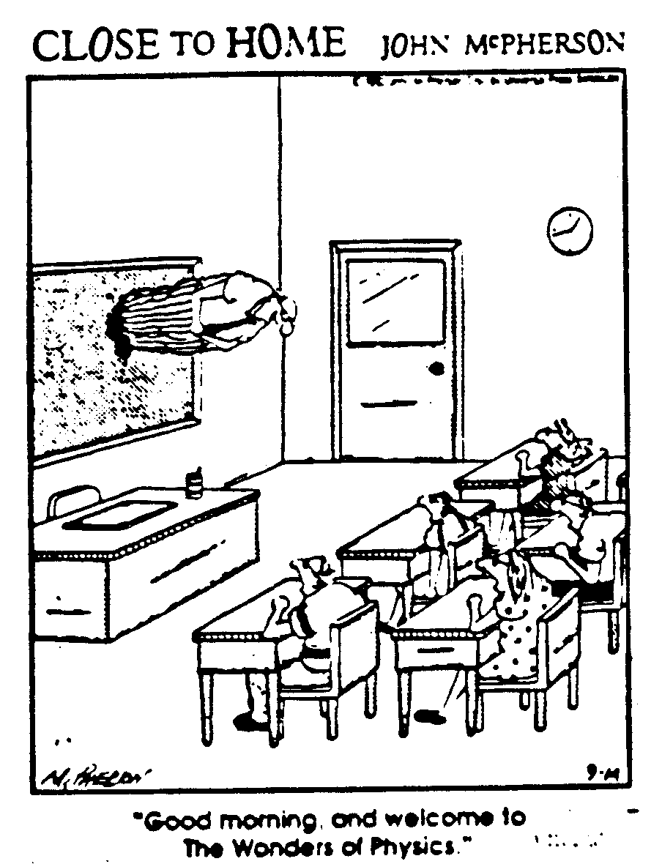

- This is Section ____ of Physics 513
- My office is located in room 294 on the second floor bridge
- My email address is jvaughan@scarsdaleschools.org
- Our class will meet in Room 304

Course Requirements
For this course, you must
- Have a way of managing all of the material handed out. I would STRONGLY suggest keeping a three ring binder. Please keep a supply of loose leaf or blank, three hole punched computer paper in your binder.
- have a non-graphing, scientific calculator
- bring your binder, calculator and a writing implement of non-bizarre color with you to class each day. Please bring pencils for lab work.

Grading Policies
The grading distribution for this course is as follows:
- Tests and Quizzes 70%
- Labs 15%
- Homework 10%
- Journals 5%
1) Tests and Quizzes - Tests will occur every 2 to 3 weeks and will always be announced a minimum of 3 days in advance.
- Quizzes will occur with much greater frequency (both announced and unannounced).
- In case of legitimate absence, tests and announced quizzes will be made up the day you return.
- In case of illegal absence, you will receive a zero on the test or quiz. It is up to you to make sure your absences are legitimate. If you are not on the daily attendance as legally absence or you haven’t talked to me beforehand, I will assume you are illegal.
2) Labs - All labs are graded out of multiples of 15 pts.
- Unless otherwise specified, labs are due one week from the in class completion of data acquisition.
- Lab policies are explained on a separate handout.
3) Homework - All homework must be done on 8 ½ by 11 paper
- Assume all homework will be collected. Therefore, do not do your homework on the back of your notes.
- Homework is graded on a plus/check/minus basis. You will begin each quarter with 7 out of 10 HW points. Each plus bumps you up a ½ point and each minus bumps you down a ½ point.
- Late homework is not accepted. Late is defined as any time after the start of class. If you left it at home or in your car, you are out of luck.
4) Journals - A journal is due approximately every other week at the start of class. Due dates are on a separate sheet.
- All journals must be typed or they will be penalized.
- Journals are scored out of 10 points.
- Journals are penalized 1 point for each day late.
- A separate handout will further explain journals.
5) Quarter Grades - Grades will be computed using the formula on the previous page.
- The grade scheme is as follows: A+ 97.0 - 100,
A 93.0 - 96.9, A- 90.0 - 92.9, and so on. I do not round quarter grades to nearest whole number.

Other Policies
1) Absence - If you are absent for a long period of time, it becomes your responsibility to make up work in a timely manner.
- If you know you will be absent, CONTACT ME as soon as possible so that arrangements can be made. When I am forewarned, I can be flexible. Showing up to class unprepared without previously speaking to me usually results in me taking a much harder line.
2) Start of Class - I begin class at the bell. I expect you to be in your seat and ready at that point.
3) Appointments - You each have a copy of my schedule.
- I carry my appointment book with me. If you sign up I will guarantee that I will be there. If you don’t sign up, please feel free to drop by but don’t get upset if I’m not there.
4) Website - I will be updating my District webpage daily. It is my hope to post all handouts and homework to this site.

